Activity No.10
Aim: Demonstration of a star topology by using cisco packet tracer.
Theory:
A star topology for a Local Area Network (LAN) is one in which each node is connected to a central connection point, such as a hub or switch. Whenever a node tries to connect with another node then the transmission of the message must be happening with the help of the central node. The best part of star topology is the addition and removal of the node in the network but too many nodes can cause suffering to the network.
In this Activity, we will discuss How to Implement Star Topology using Cisco Packet Tracer.
A Cisco packet tracer is a simulation tool that is used for understanding the networks. The best part of the Cisco packet tracer is its visualization you can see the actual flow of the message and understand the workflow of the network devices. Implementation of Star Topology using Cisco Packet Tracer is done using Switch.

Steps Implementing Star Topology using Cisco Packet Tracer:
Step 1: We have taken a switch and linked it to six end devices.

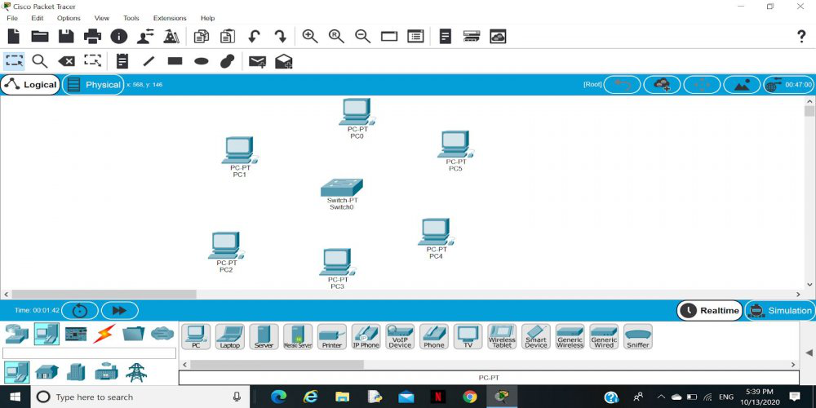
Step 2: Link every device with the switch.
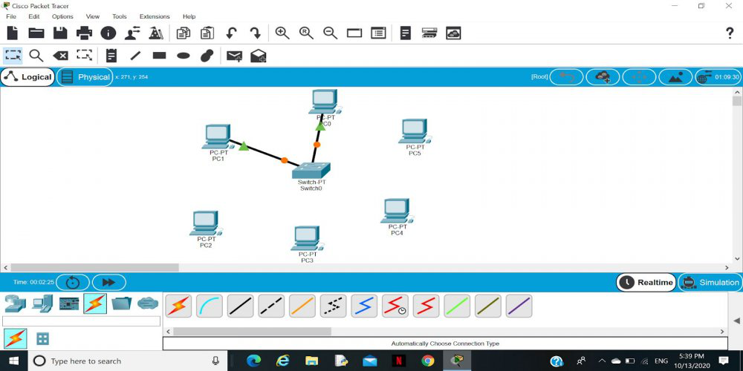
Step 3: Provide the IP address to each device.
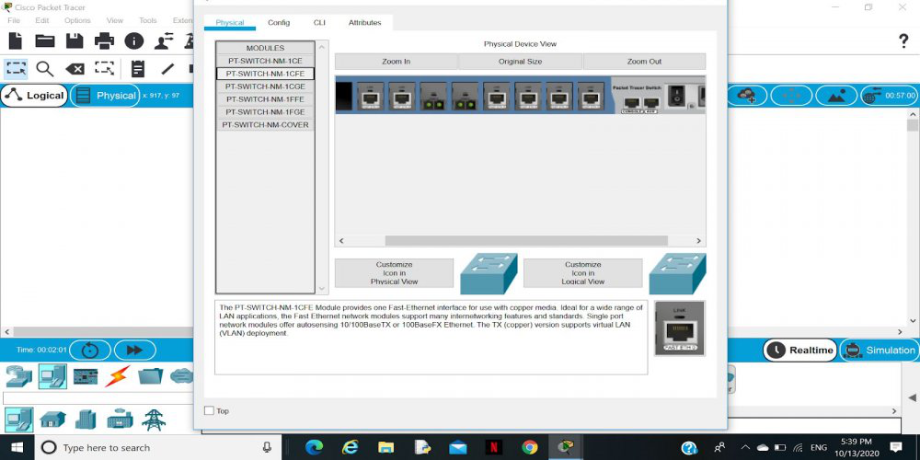
Step 4: Transfer message from one device to another and check the Table for Validation.
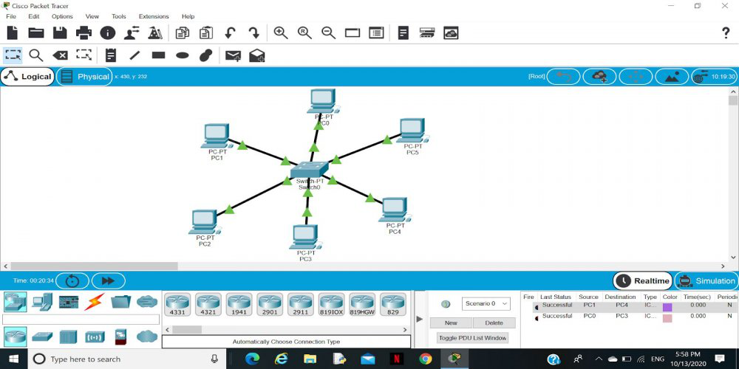
Now to check whether the connections are correct or not try to ping any device and the image below is doing the same.
To do ping one terminal of one device and run the following command:
Command:
"ping ( ip_address_of _any_device ) "
Example:
ping 192.168.1.4

Note: If the connections are correct
then you will receive the response.
